**Ideation Phase**

**deap learning fundus image analysis for early detection of diabetic retinopathy**

|  |  |
| --- | --- |
| Date | 20 September 2022 |
| Team ID | PNT2022TMID41310 |
| Project Name | deap learning fundus image analysis for early detection of diabetic retinopathy |
| Maximum Marks | 4 Marks |

**Abstract**

Nowadays lots of the people have detected with diabetes and diabetes is the reason behind the cause of Diabetic Retinopathy (DR) at higher level. And this leads to blurry vision, poor night vision, decreased field of vision, increased number of eye floaters, loss of vision, distorted vision among the population. Very frequently people are diagnosed with some or the other stage of DR. If there is in time and proper detection of DR then the vision impairments can be forestalled in majority of DR cases. But the detection of the DR is too difficult at such early stage even with the present tools, as the symptoms can be seen at the very later stage of the disease. Thus, there is the need for an automated and broad-ranging method of DR screening which can be done using Deep Learning. So here grayscale fundus photographs have used and Convolutional Neural Network (CNN) model is used for the detection of DR as presently results suggests that Neural Network have good clinical potential. DR detection is done for five stages No DR, Mild, Moderate, Severe, Proliferative categorized on four age groups. Keywords: Diabetic Retinopathy, Deep Learning, Grayscale, Convolutional Neural Network, Neural Network Fundus photov graphs.

**Introduction**

Diabetic retinopathy (DR) is also called diabetic eye disease, when retina is damaged due to diabetes. It can eventually lead to blindness. It is an ocular manifestation of diabetes. Despite these intimidating statistics, research indicates that at least 90% of these new cases could be reduced if there is proper treatment and monitoring of the eyes [1]. Diabetic retinopathy can be categorized into 4 stages: Mild non-proliferative, Moderate non-proliferative, Severe non-proliferative and Proliferative. Here the Non-proliferative type is the early stage and Proliferative is advance stage of DR. The various markers of diabetic retinopathy are micro aneurysms, retinal swellings, damaged nerve tissues, growth of abnormal new blood vessels and leaking blood vessels. At the early-stage symptoms are not caused so not possible to know because blood vessels mostly do not leak in these early (non-proliferative) stages so detection of DR is very much difficult. But with the help of examination of eye DR can be detected at the early stages. Symptoms for proliferative DR can include blurry vision, poor night vision, decreased field of vision, increased number of eye floaters, loss of vision, distorted vision etc [2]. Importance for detection of diabetic retinopathy is at the early stage if the DR is not detected then the severe problem may be caused so if the DR is detected at the early stage it may help to reduce risk of sever problems so the DR screening is needed to detect the issues early.

# PROPOSED SYSTEM

This system takes image processing technique for the detection of DR. There are several algorithms proposed on existing, but here for classification, we will use Convolutional Neural Network (CNN algorithm). The dataset will be grayscale images with a different 5 categories like No DR, Mild, Moderate, Severe, Proliferative DR. Then analyze and classify these data with Deep network. Also, we will categorize dataset to 4 different age groups and then images will be used for DR detection and prediction.

# PROPOSED MODEL

# 

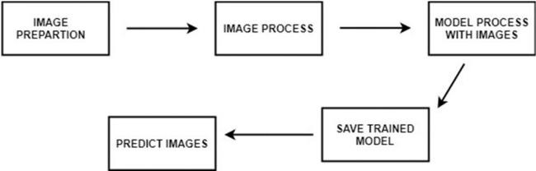

Figure 1 above shows proposed model diagram. Dataset is taken from Kaggle, data set has grayscale fundus retinal 923 images. We will use Convolutional Neural Network (CNN) for training and prediction. Firstly, we will train the model using labelled training images. After tr model is trained we will use the trained model for validation and testing purpose.

We will predict DR based on five stages which are No DR, Mild non proliferative, Moderate non proliferative, Severe non prolifera-tive, Proliferative and 4 categories of age group. Also, we will find the accuracy, validation accuracy, loss, validation loss after training the model. Implementation will be performed using anaconda navigator software in python language.

CNN is the deep learning technique to which we will give input image and learnable weights and biases are assigned to different as-pects in the image so as to be able to differentiate from one another. Here pre-processing required is very less in ConvNets com-pared to other classification algorithms. ConvNets are inspired from human biology, they are comprised of various layers such as filter banks, non-linearities, feature pooling layers. With the help of these layers ConvNets are able to learn lots of features.

**METHODOLOGY**

*A. Deep Learning Approach*

Deep learning is type of ML and a subset of AI, where Machine Learning is one of the methods to analyze the data that automates analytical model building. Machine learning could be a branch of AI supported the thought that systems will learn from knowledge, distinguishing patterns and create choices with less human intervention. For sentiment analysis machine learning tools are trained with samples of emotions in text, afterwards machines learn to detect sentiment without human input automatically. So, we can say simply that machine learning allows computers to learn new tasks without being specially programmed to perform them. Deep learning makes use of artificial neural network for performing massive computation on huge data. it works similar to neurons in human brain. There are various techniques and complex algorithms which are used to train machines and perform sentiment analy-sis they can be classified under Supervised Learning and Unsupervised Learning [27].

*B. Algorithm*

CNN Algorithm is used. The basic Convolutional Neural Network (CNN) diagram is shown in the figure below. A ConvNet/CNN is a Deep Learning algorithm which takes in an input image, then assign learnable weights and biases i.e., importance to various ob-jects/aspects in the image so as to be able to differentiate from each other. Very less pre-processing is required in a ConvNet as compared to other classification algorithms. Here, in the other primitive methods filters are hand-engineered, with use of enough training, where ConvNets have the ability to learn these filters/characteristics. ConvNet architecture is similar to that of the connec-tivity pattern of Neurons in the Human Brain and was inspired by the organization of the Visual Cortex [28].



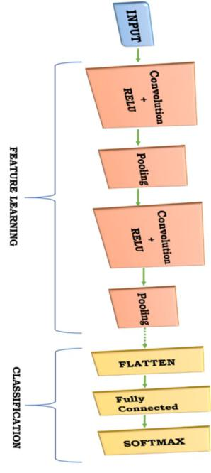

Convolutional Neural Network

*C. Model*

VGG 16 is CNN architecture which was used to win ILSVR(Imagenet) competition in 2014. Most importantly, they have focused on having convolution layers of 3x3 filter with a stride 1 and always used same padding and maxpool layer of 2x2 filter of stride 2, instead of having a large number of hyper-parameters. This arrangement of convolution and max pool layers is followed consistent-ly throughout the whole architecture. In the end it has two fully connected layers which are followed by a softmax layer for output. The 16 in VGG16 is refered as it has 16 layers which have weights. This vgg16 network is fairly large network and it has approxi-mately 138 million parameters [30].

*D. Flow Diagram*

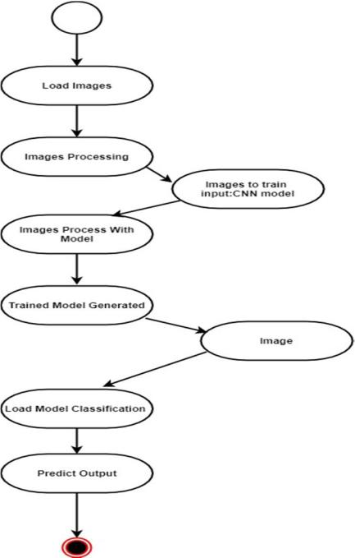

**CONCLUSION**

The enormous people are diabetic patients and the inescapability of DR among them have developed an extraordinary interest in modified DR diagnosing structures. So here grayscale fundus photographs have used and Convolutional Neural Network (CNN) model is used for the detection of DR as presently results suggests that Neural Network have good clinical potential. DR detection is done for five stages No DR, Mild, Moderate, Severe, Proliferative categorized on four age groups (Group A, B, C, D). The main ad-vantage of CNN is that it detects all the important features automatically and learns peculiar features of each class by itself. CNN is very efficient computationally. In further work we can increase more accuracy and accurate prediction rate, we can implement the proper hardware software system for above DR detection using raspberry pi and create a system which will detect the stage of DR and depending upon that it will guide showing the reference of particular hospitals or good doctors, can generate proper report so as to show it to the doctor.